

P

r

o

j

e

c

t

R

e

p

o

r

t

1

I

N

T

R

O

D

U

C

T

I

O

1

.

1

O

v

e

r

v

i

e

w

Bright Ideas Consulting, a consulting firm, relies on ZOHO Books to track their billable hours, expenses, and client invoices. Bright Ideas Consulting is a Private Limited company also registered under GST in Tamil Nadu. Bright Ideas Consulting offers various expert consulting services in India and outside India.

* 1. Purpose
* Preparation and Maintenance of ZOHO Books for Dream Homes Realty, a construction company, uses ZOHO Books to track project expenses, manage subcontractor payments, and handle invoicing.
* Dream Homes Realty, a construction company, uses ZOHO Books to track project expenses, manage subcontractor payments, and handle invoicing. They can generate estimates and invoices for clients, track job costing, and monitor the profitability of each project. ZOHO Books provides them with financial insights to make informed decisions.

2.1 Empathy Map

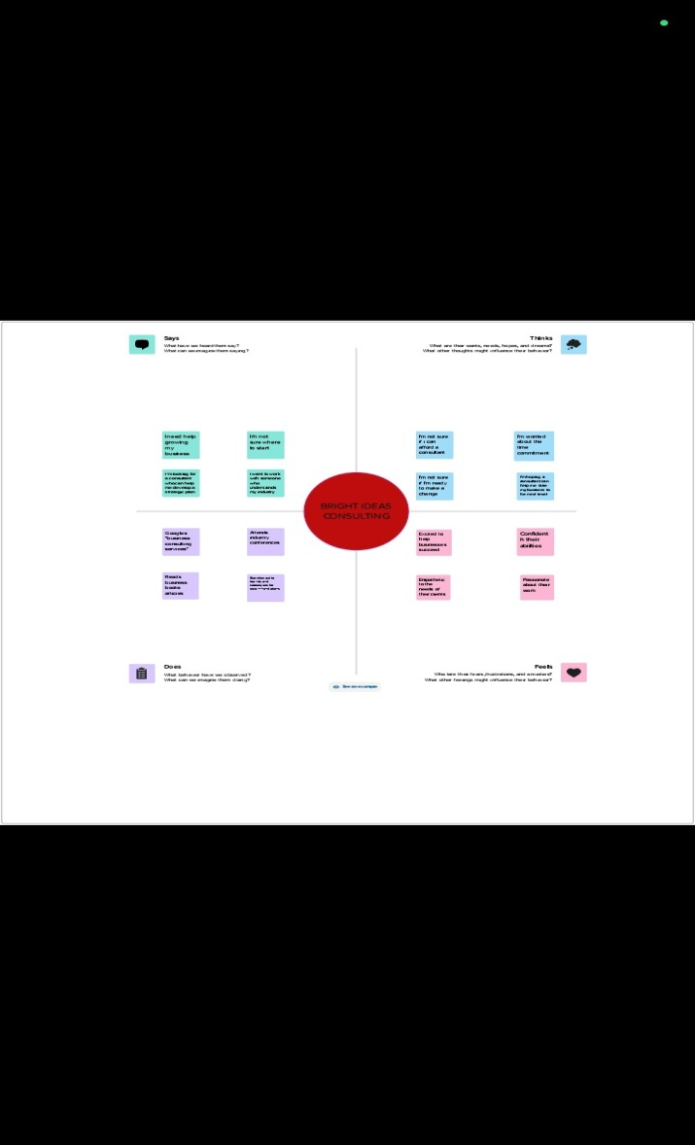



2.2 Ideation & Brain Storming Map

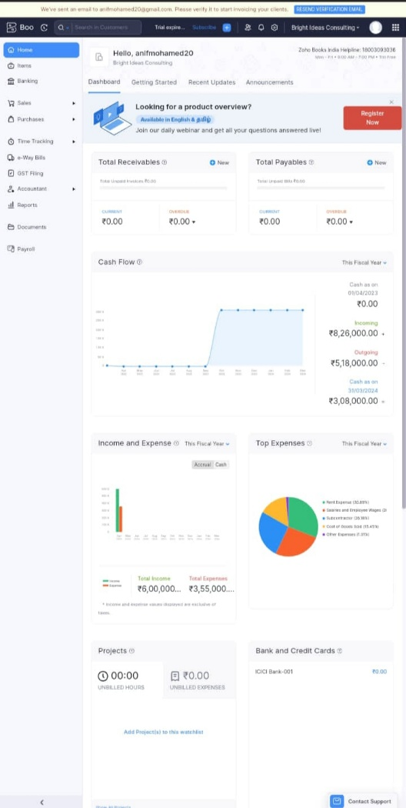

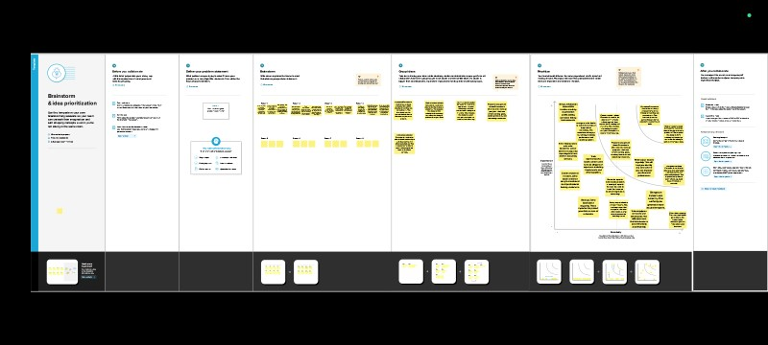

3

E

S

]U

L

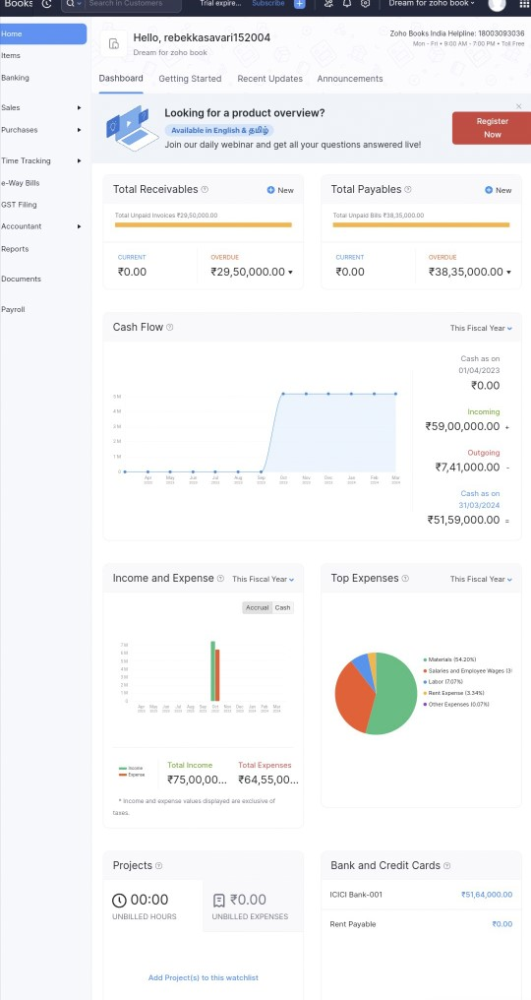

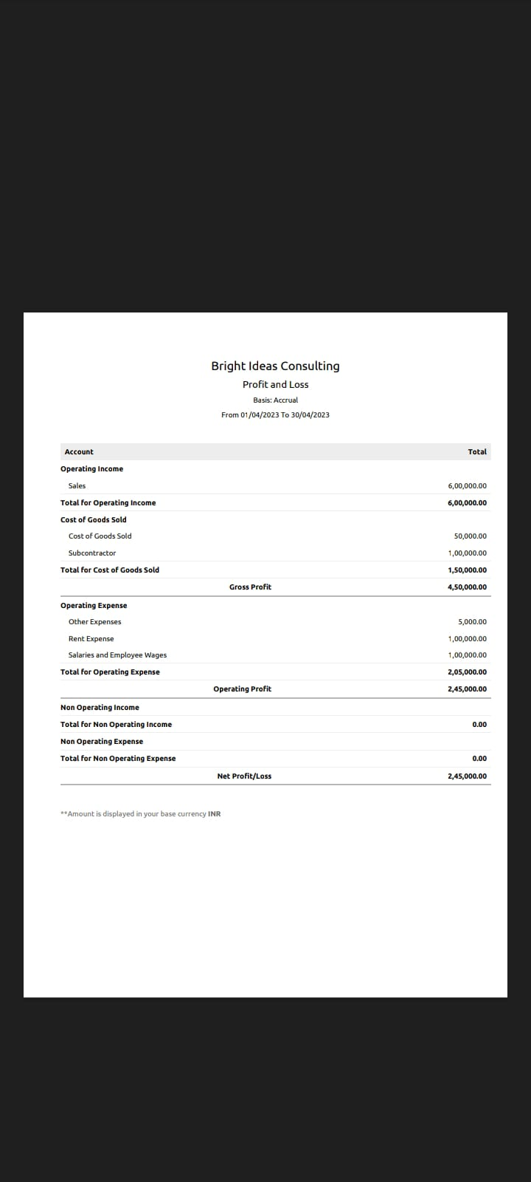

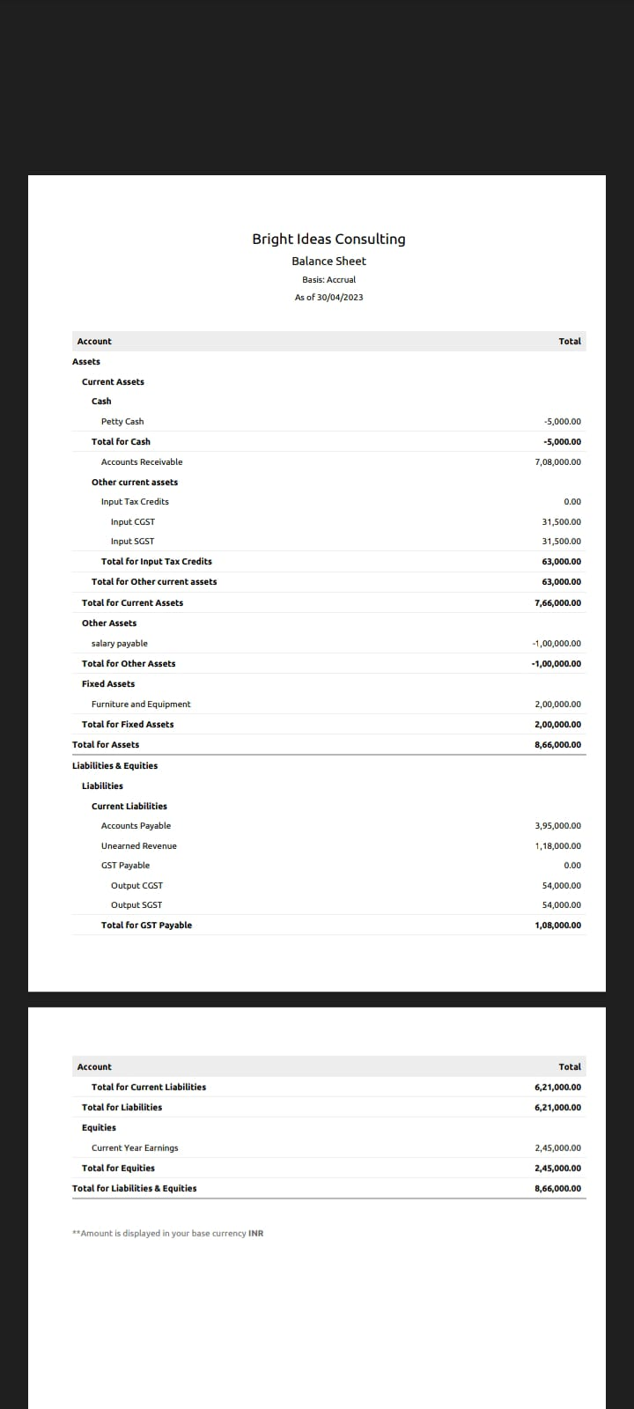

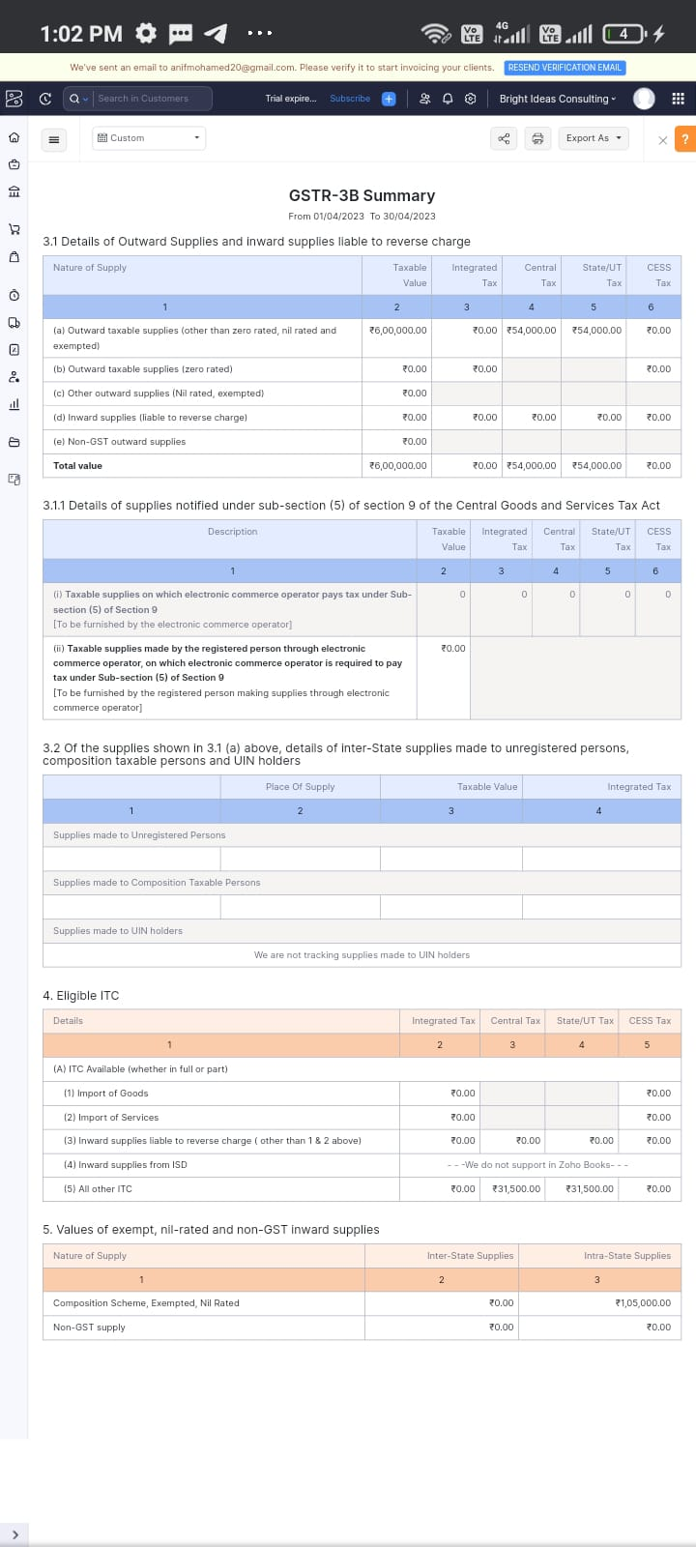

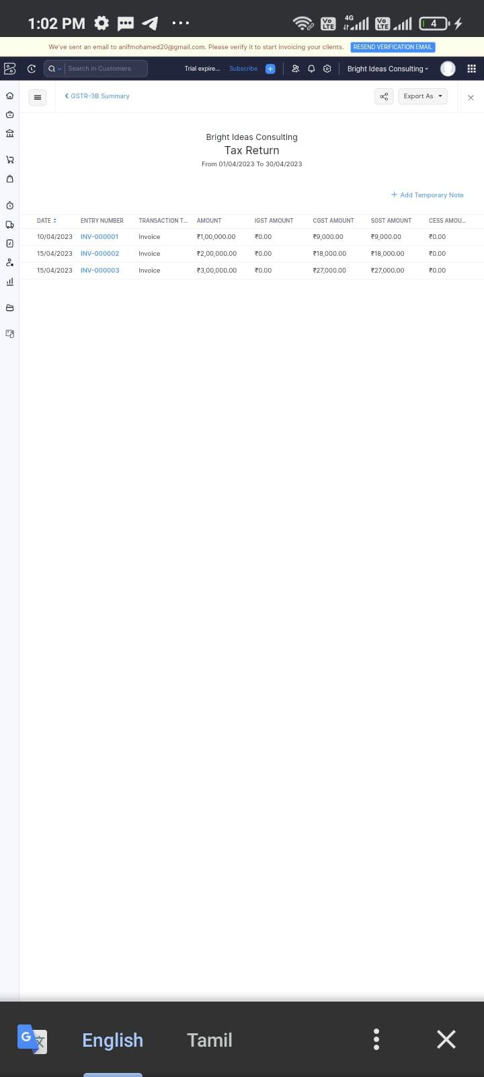

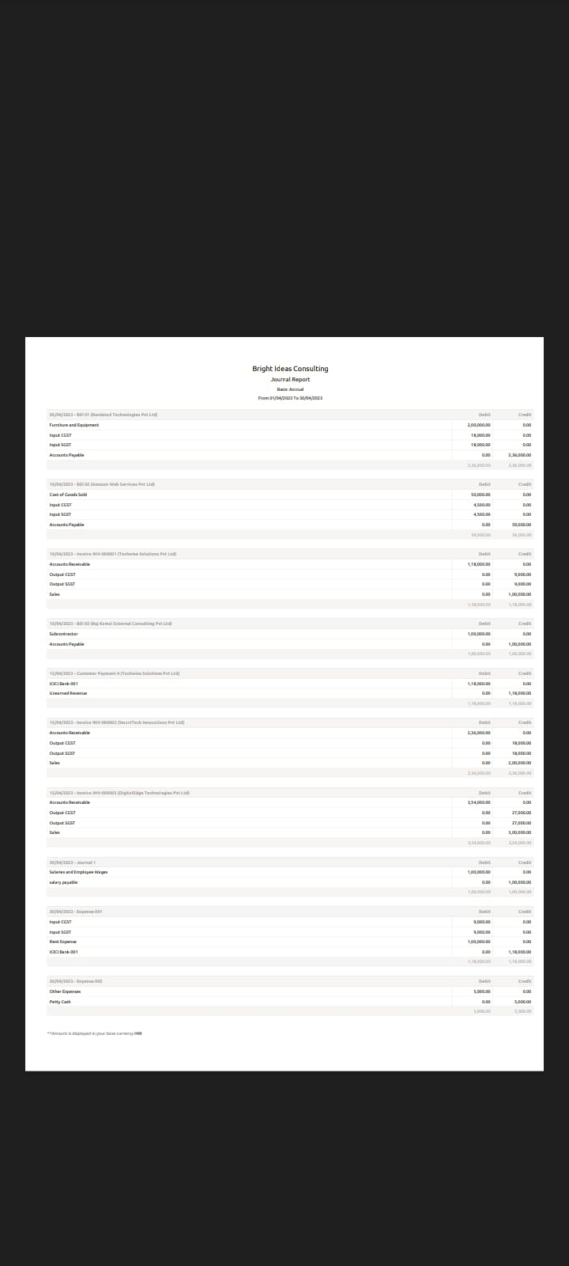



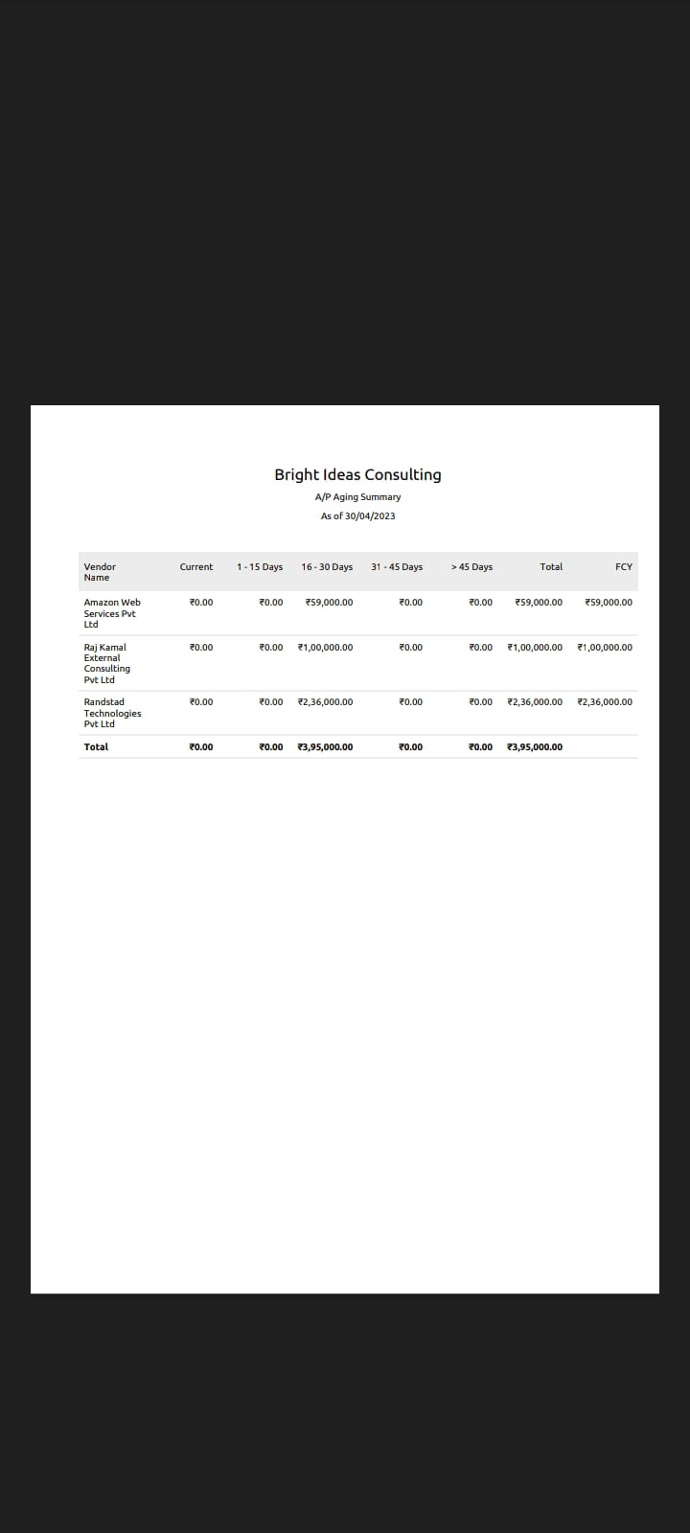

1.Advantages



4

A

D

V

A

N

T

A

G

E

S

&

D

I

S

A

D

V

A

N

T

A

G

E

S

* Rent payments may be lower
* Repairs aren't your responsibility:
* Flexibility
* No HOA dues
* Low upfront costs
* Privacy
* Usually a good investment

More stable housing costs from year to year

* Pride in ownership and strong community ties
* Equity buildup (savings)

2.Disadvantages

* It can be difficult to change the property
* You aren't building value ● Rent may increase
* No cosmetic improvements
* No credit score improvement
* Long-term commitment
* Maintenance and repair costs
* Lack of flexibility
* Usually more expensive than renting
* High up-front costs
* Foreclosure

Bright Ideas Consulting, a consulting firm, relies on ZOHO Books to track their billable hours, expenses, and client invoices. The software helps them accurately calculate project costs, monitor profitability, and generate reports for better financial management.

Bright Ideas Consulting Ltd. Creates innovative, evidence-based solutions, to enable organizations and the individuals who interact with them to thrive .We predominantly work with organizations who have a social mission including voluntary & community sector organizations.



7

F

U

T

U

R

E

S

C

O

P

E

Dream home realty, encompasses various segments, including residential, commercial, retail, hospitality, and industrial properties. The rapid urbanization, growing middle class, and increased investment in infrastructure have driven the demand for real estate across these segments

1. Nest

If you want to live in Kongara Kalan near TCS Adibatla, you'll find the Nest Apartments perfect. The HMDA-approved and RERA-registered luxury apartment project is in a 1.03acre area with 47 flats and excellent sports facilities.

1. Emerald Heights:

Emerald Heights is among the residential projects in Hyderabad in a clean and pollution-free neighbourhood near Uppal, Singapore Township, Infosys SEZ, and Mindspace IT Park. The premium Apartment project includes 895 flats in a 10.2-acre area with two phases.

1. Paradise Homes

premium apartment project in Hayathnagan, Paradise Homes offers 427 flats spread over a four-acre area. Phase 1 has 101 apartments, and Phase 2 has 326, all with luxury specifications, Vaastu-compliant, and good lighting and ventilation.

# 

A .Source Code